1. Go to Databrick Community, and sign up

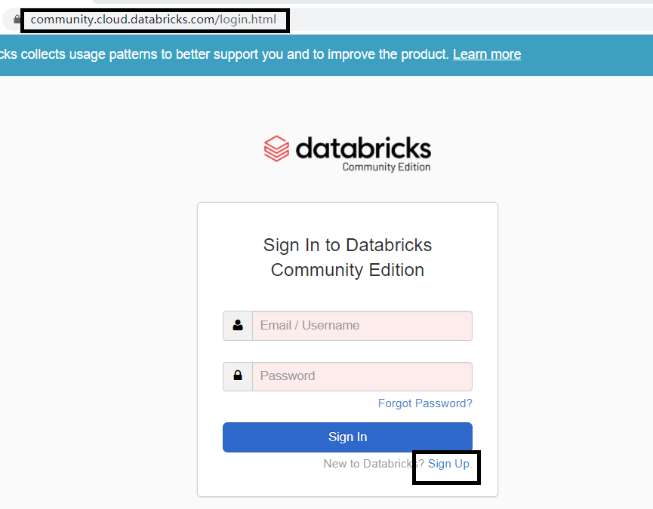

1. Log in

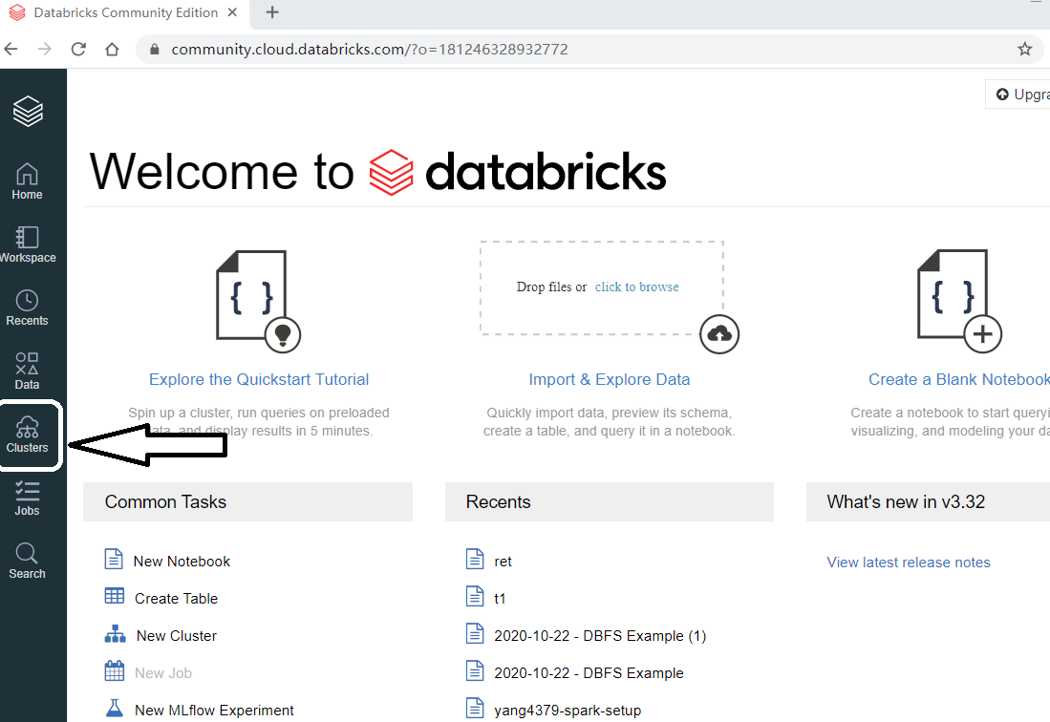

1. Go to “Clusters” and create a cluster using default settings.

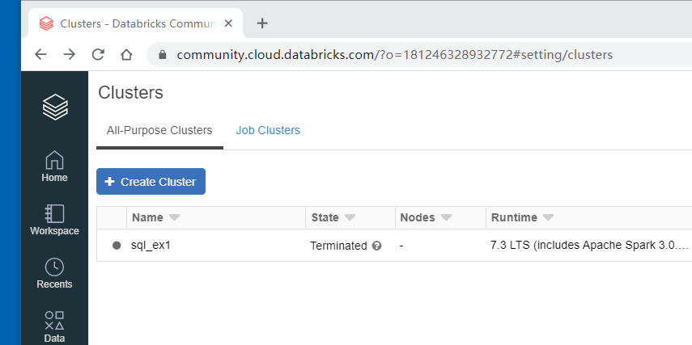

1. Wait until Cluster is running as follows.

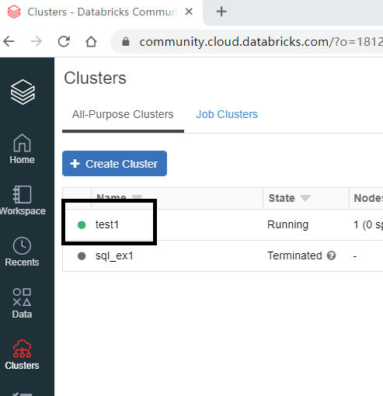

1. go to Data. If the data tab says there is no cluster, refresh your browser.

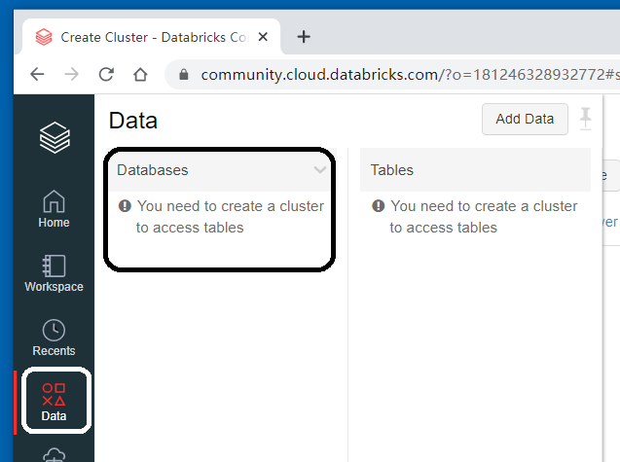

1. Select Default or create a new database. Then go to “Add Data”.

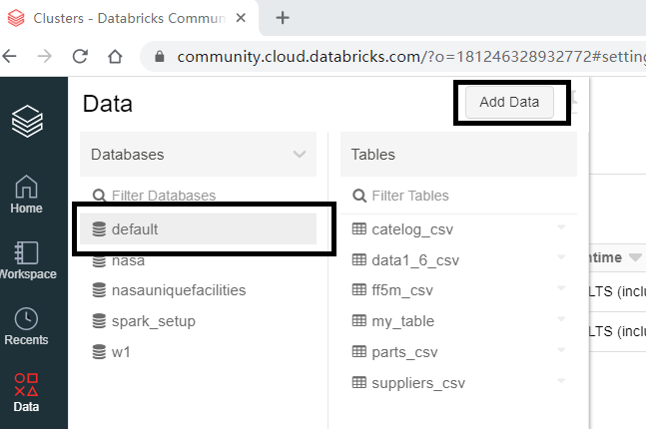

1. Select the CSVs to upload data 🡪 Create table with UI 🡪 Select the cluster you just created 🡪 Preview Table

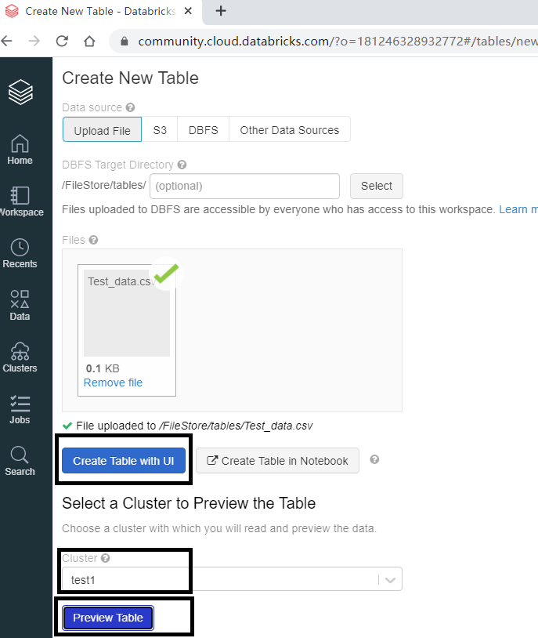

1. Change table name if need; Check “First row is header” if applicable; select appropriate data type; Click “Create Table”.

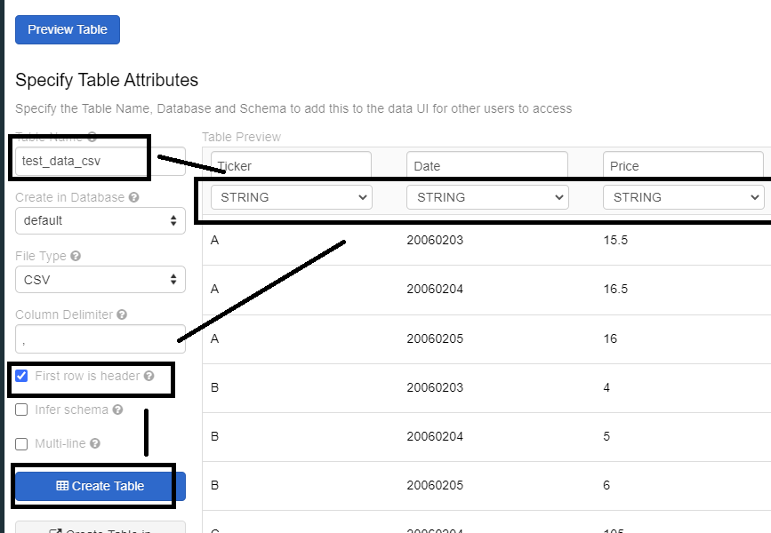

1. Click the top Icon, then create new notebook, python or SQL.

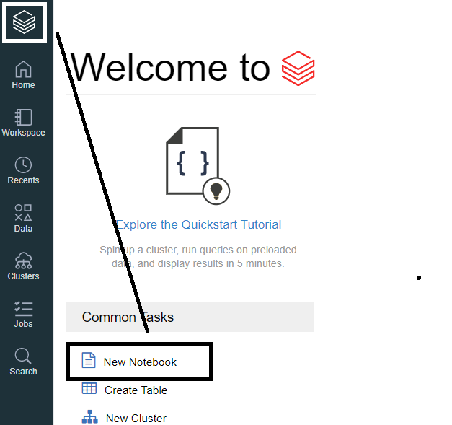

1. For example, create a SQL notebook and run some queries.

